**Personal Portfolio 2**

(Group Number:43)

(Anqi Yan – n9919180)

(<https://bitbucket.org/anqiyan/ifb299carrental/src/master/>)

(git clone https://anqiyan@bitbucket.org/anqiyan/ifb299carrental.git)

**Artefact 1 – (Car recommendation function)**

This artefact is related to function which is required by our client – Car type recommendations to customers. This function provides useful information to customers for them to easier choose which car to rent, it allows them to select year, month and city in the data fields and click “Recommend Me” button, then the top amount of car in this period or city will be displayed as text format which is easy to read. This function is very easy to use, for example, if user select nothing and click ‘Recommend me’ button, system will tell user which is the top amount of car in the total order (figure.1), if user only select year, then system will show which is the top amount of car in this year to user (figure.2), if user select year, month and input city, the system will show result to user based on their selection (figure.3), if user only input city, system will show which is the top amount of car in this period to user and number of car in total the total of this month (figure.4). This artefact fulfilled the requirement asked by our client and could make our project better. (This function is done by me. *not including layout part)

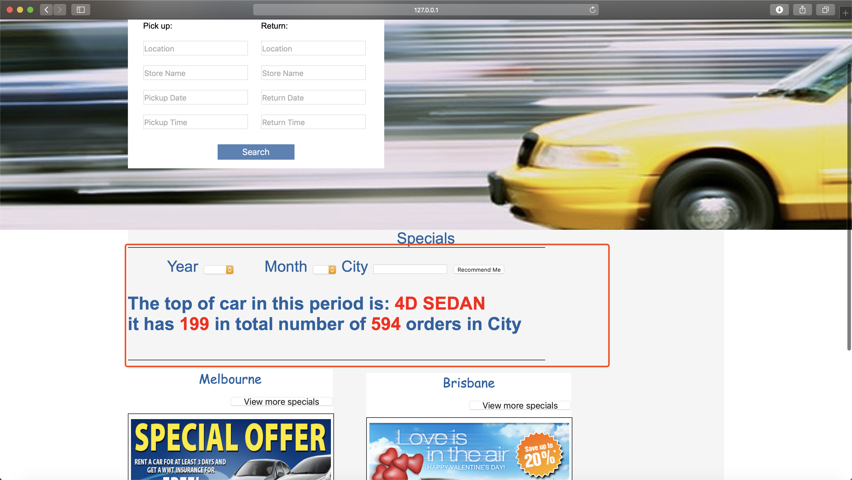

(figure.1 above)

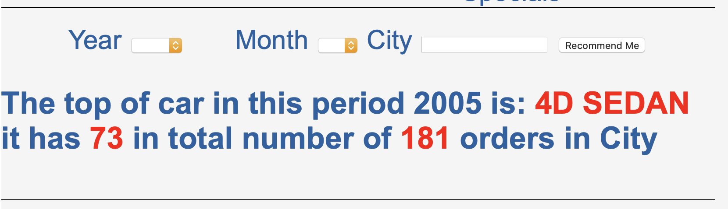

(figure.2 above)

Year: 2005 and month: 07 in Sydney

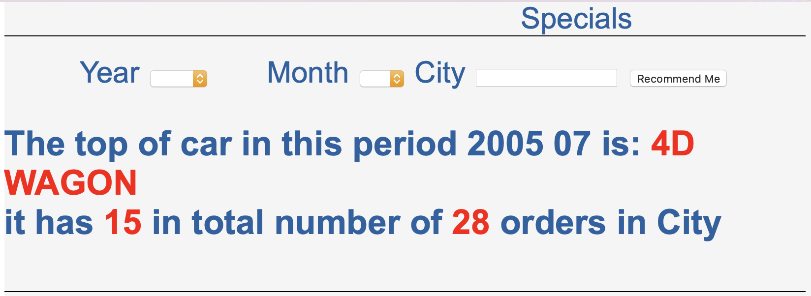

(Figure.3 above)

Total in Sydney without selection of year and month

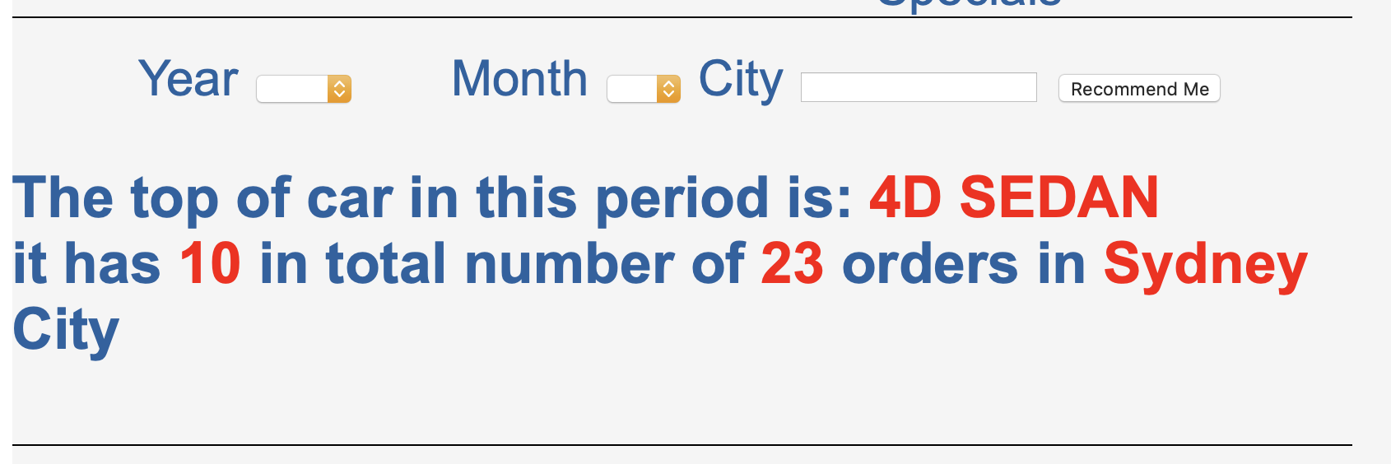

(figure.4 above)

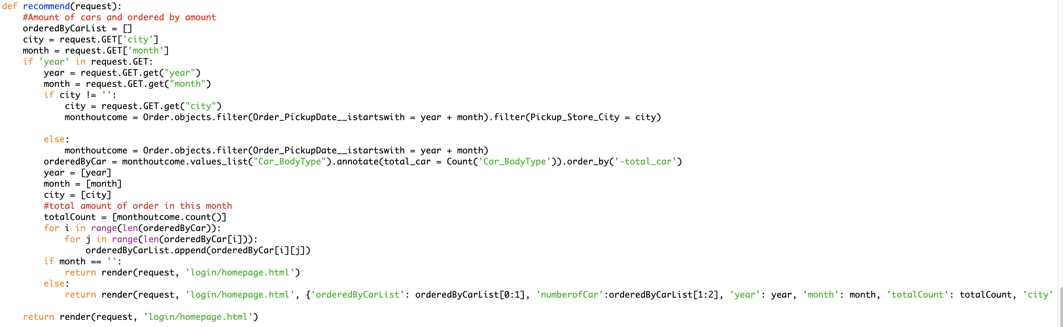

Above code is related to car recommendation function

**Artefact 2 – (Monthly outcome)**

This artefact is related to function - monthly outcome check which is required by our client. This function shows Car ID, Type, Name, Store Address and number of pickup or return in the table, our client can get figures what they need very clearly. Our clients are able to check data based on their selection such as based on year, month or store. On the top of page, it indicates selection made by user. It is easy to use as well, if user click search button without any selection, system will show total order records in the table (Figure.1) with necessaay figure such as number of pickup or return in different store. If user select year and month, system will show related data as well (Figure.2). This function fullfilled the requirement ask by our client which is very useful for them to alanyse data. (This function is done by Chengming Guo and me together *not including layout part of page)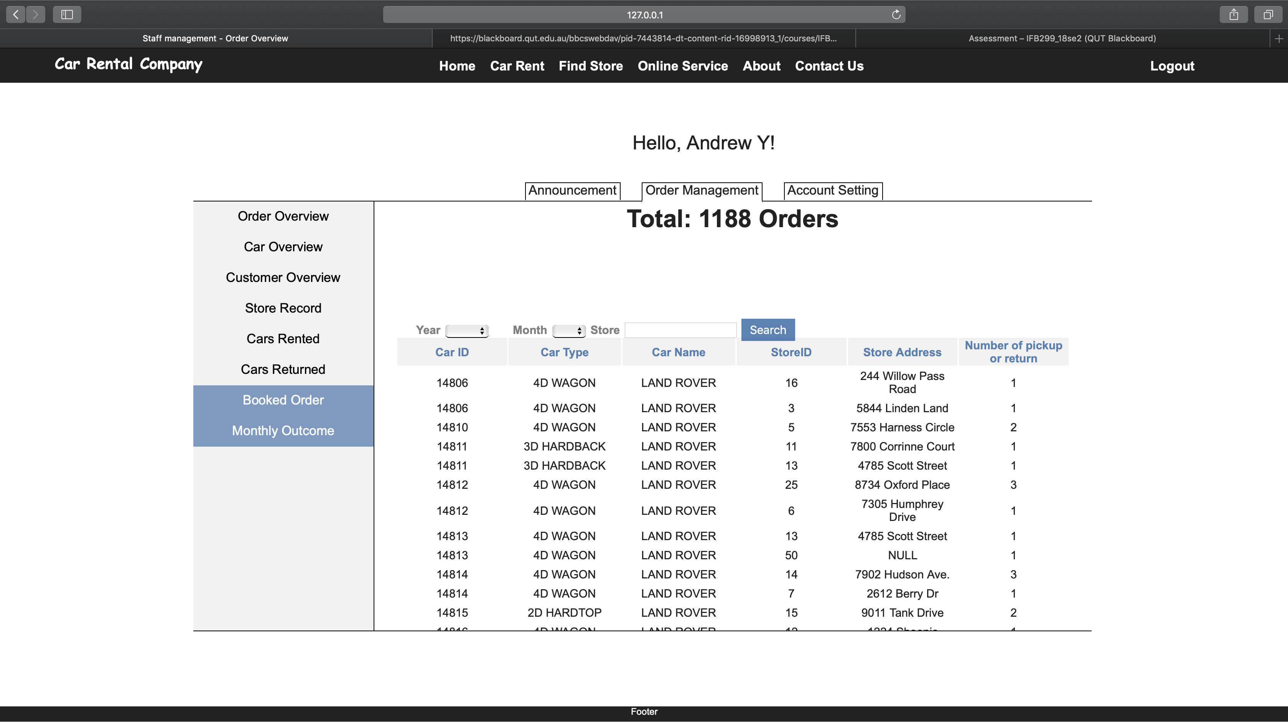

(Figure.1)

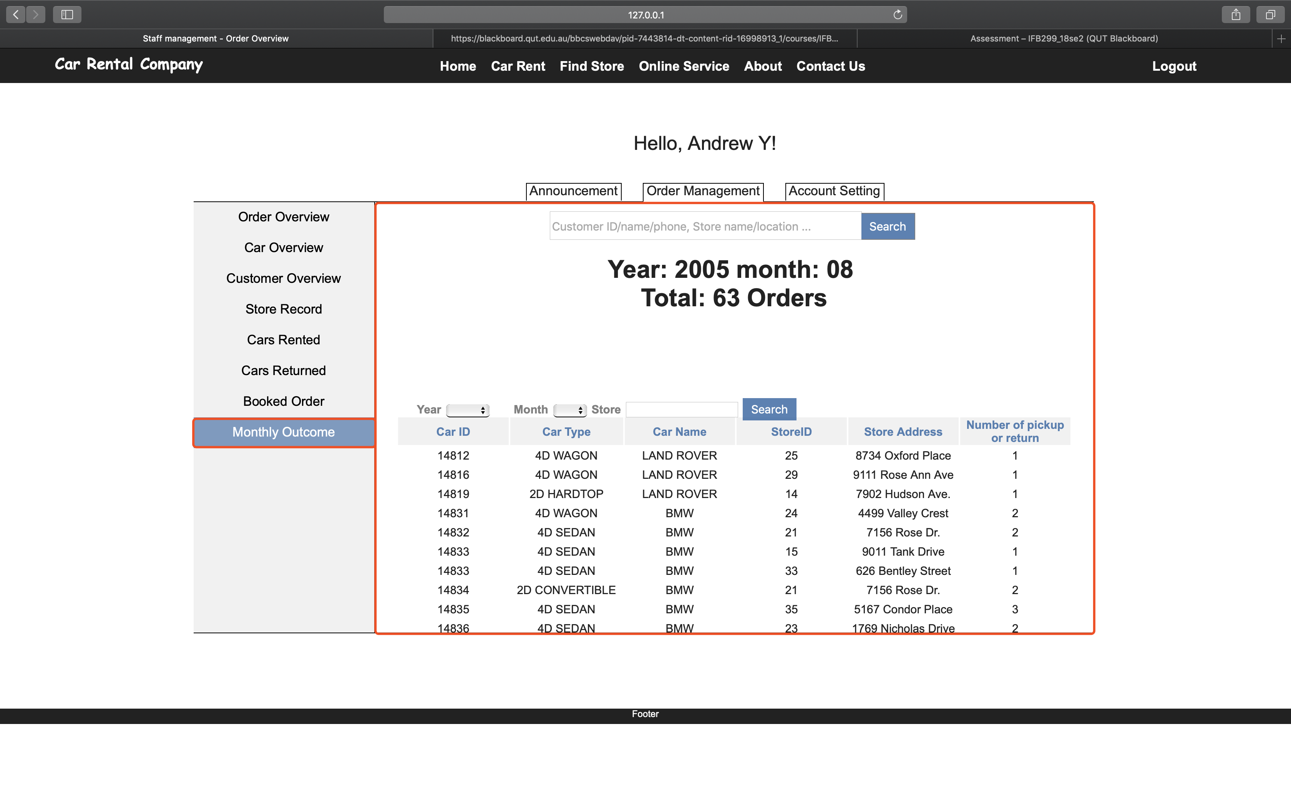

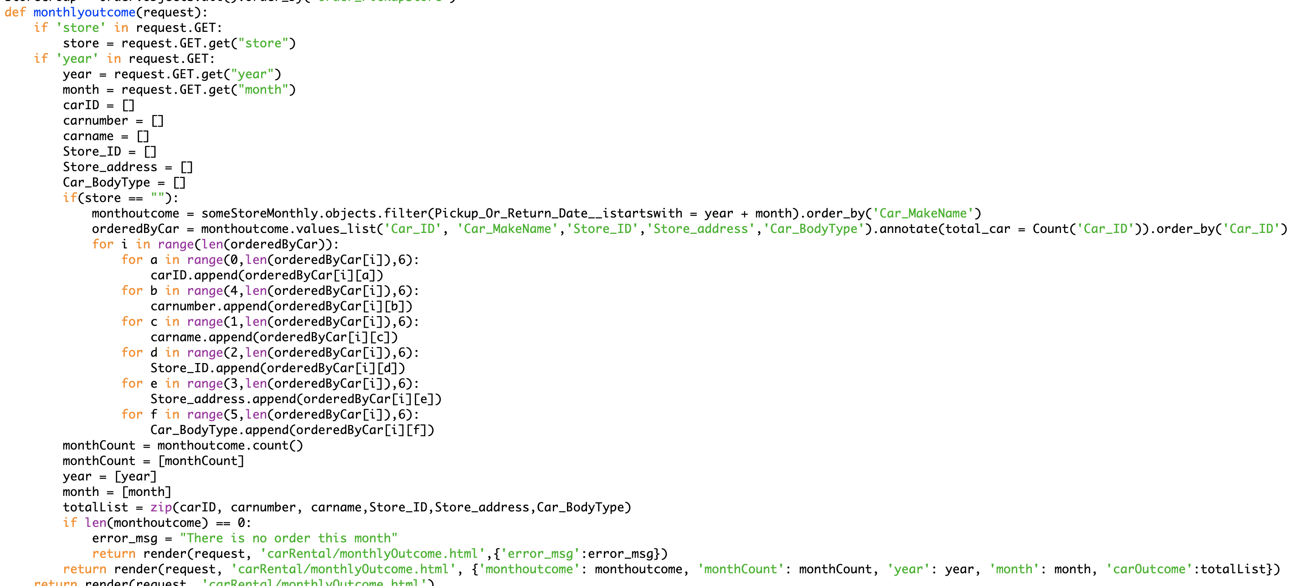

(Above code is related to monthly outcome function)

**Artefact3(Contact us page)**

This artefact is related to ‘Contact Us’ page development. First of all, we have made a mock up page and gave to some people and asked them to provide feedback, then we developed this page based on those feedback. This page is necessary in our project, if user wants to contact Car Rent Company, they could send enquiries to CRC through this page, it is very efficiency way to ask questions. In this form, user need to provide their personal details such as name, username, email, phone number, preferred contact method, which kind of enquiry, who you want to send and details of enquiry, these data are necessary for CRC to know the enquiry better, then user could submit this form by just clicking ‘Submit’ button, then Car Rental Company could receive enquiry email from user. (Functionality haven’t done yet just done partial, will continue develop in the future, this artefact is done by Jamie and me).

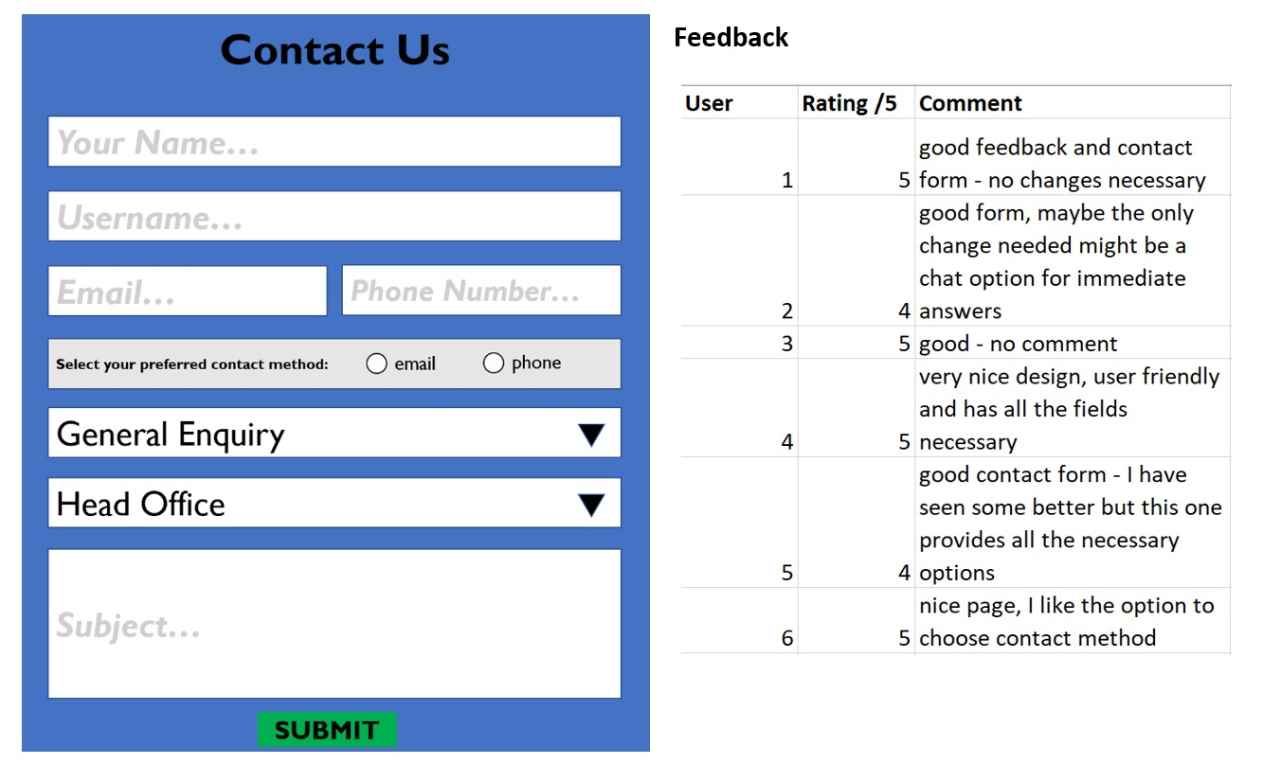

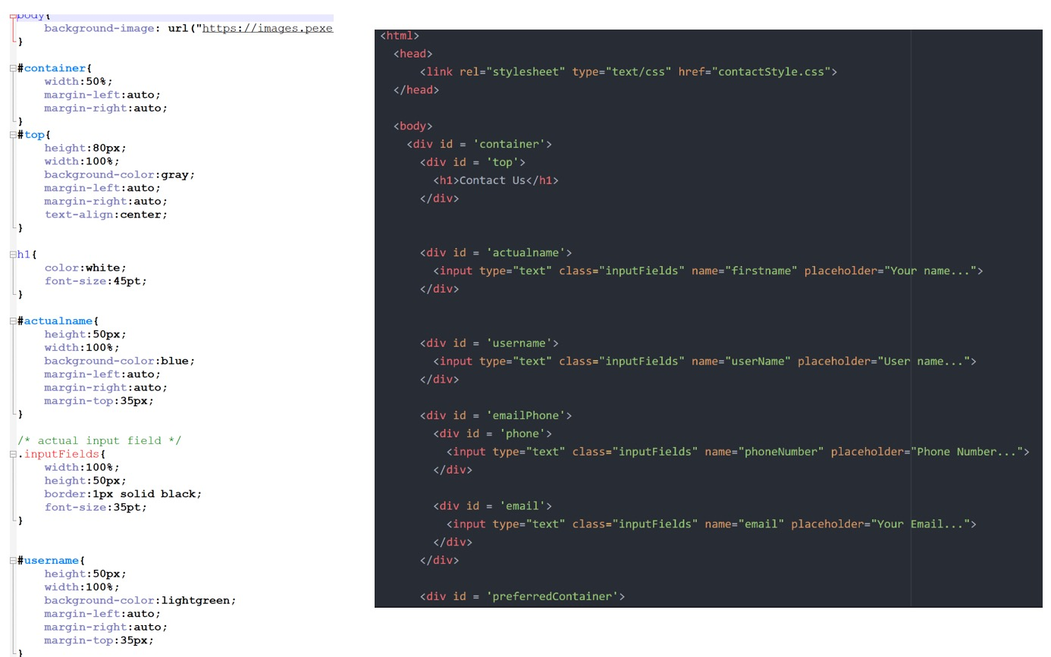

We have clear structure and meaningful name in the code, so it is easy to continue develop and maintain

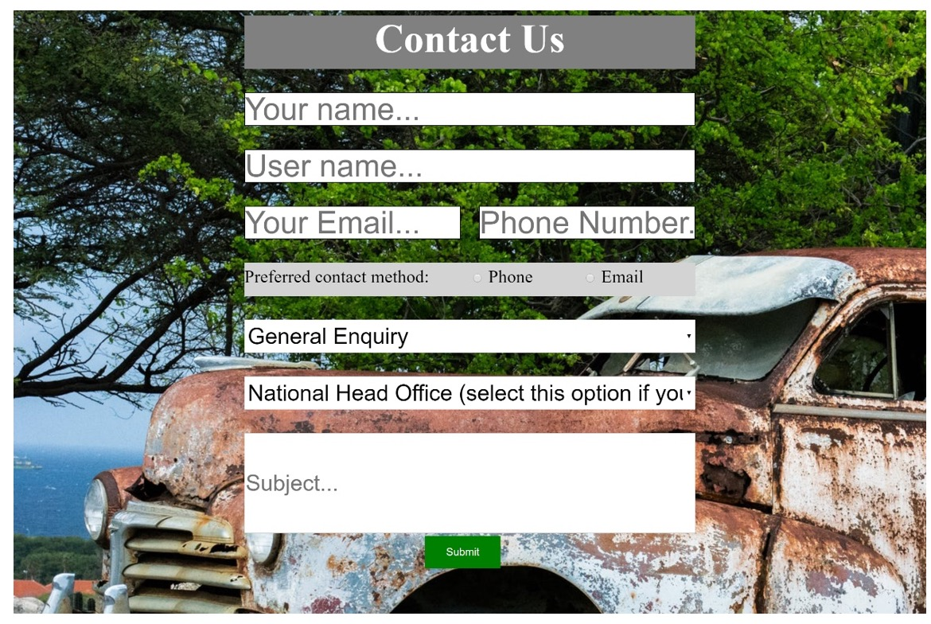

**Artefact4(Test data in Car Recommendation Function)**

This artefact is related to data test. Data test is very important in this project because it has connected with a lot of data in the database, our team did a lot of tests in this project for Car Rental Company, it is important to keep data accurately, especially in car recommendation system, this system can count number of each car type based on user selection then provide relative information to user. I have tested car recommendation system with following steps: 1. Test if data is correct without any selection. 2.Test if data is correct with select different year. 3.Test if data is correct with select different year and month. Result is all of data shows correctly on the page compared to database. With this artefact, our team can make sure our project is in very high accuracy level and our clients are happy to use (This artefact is done by myself.)

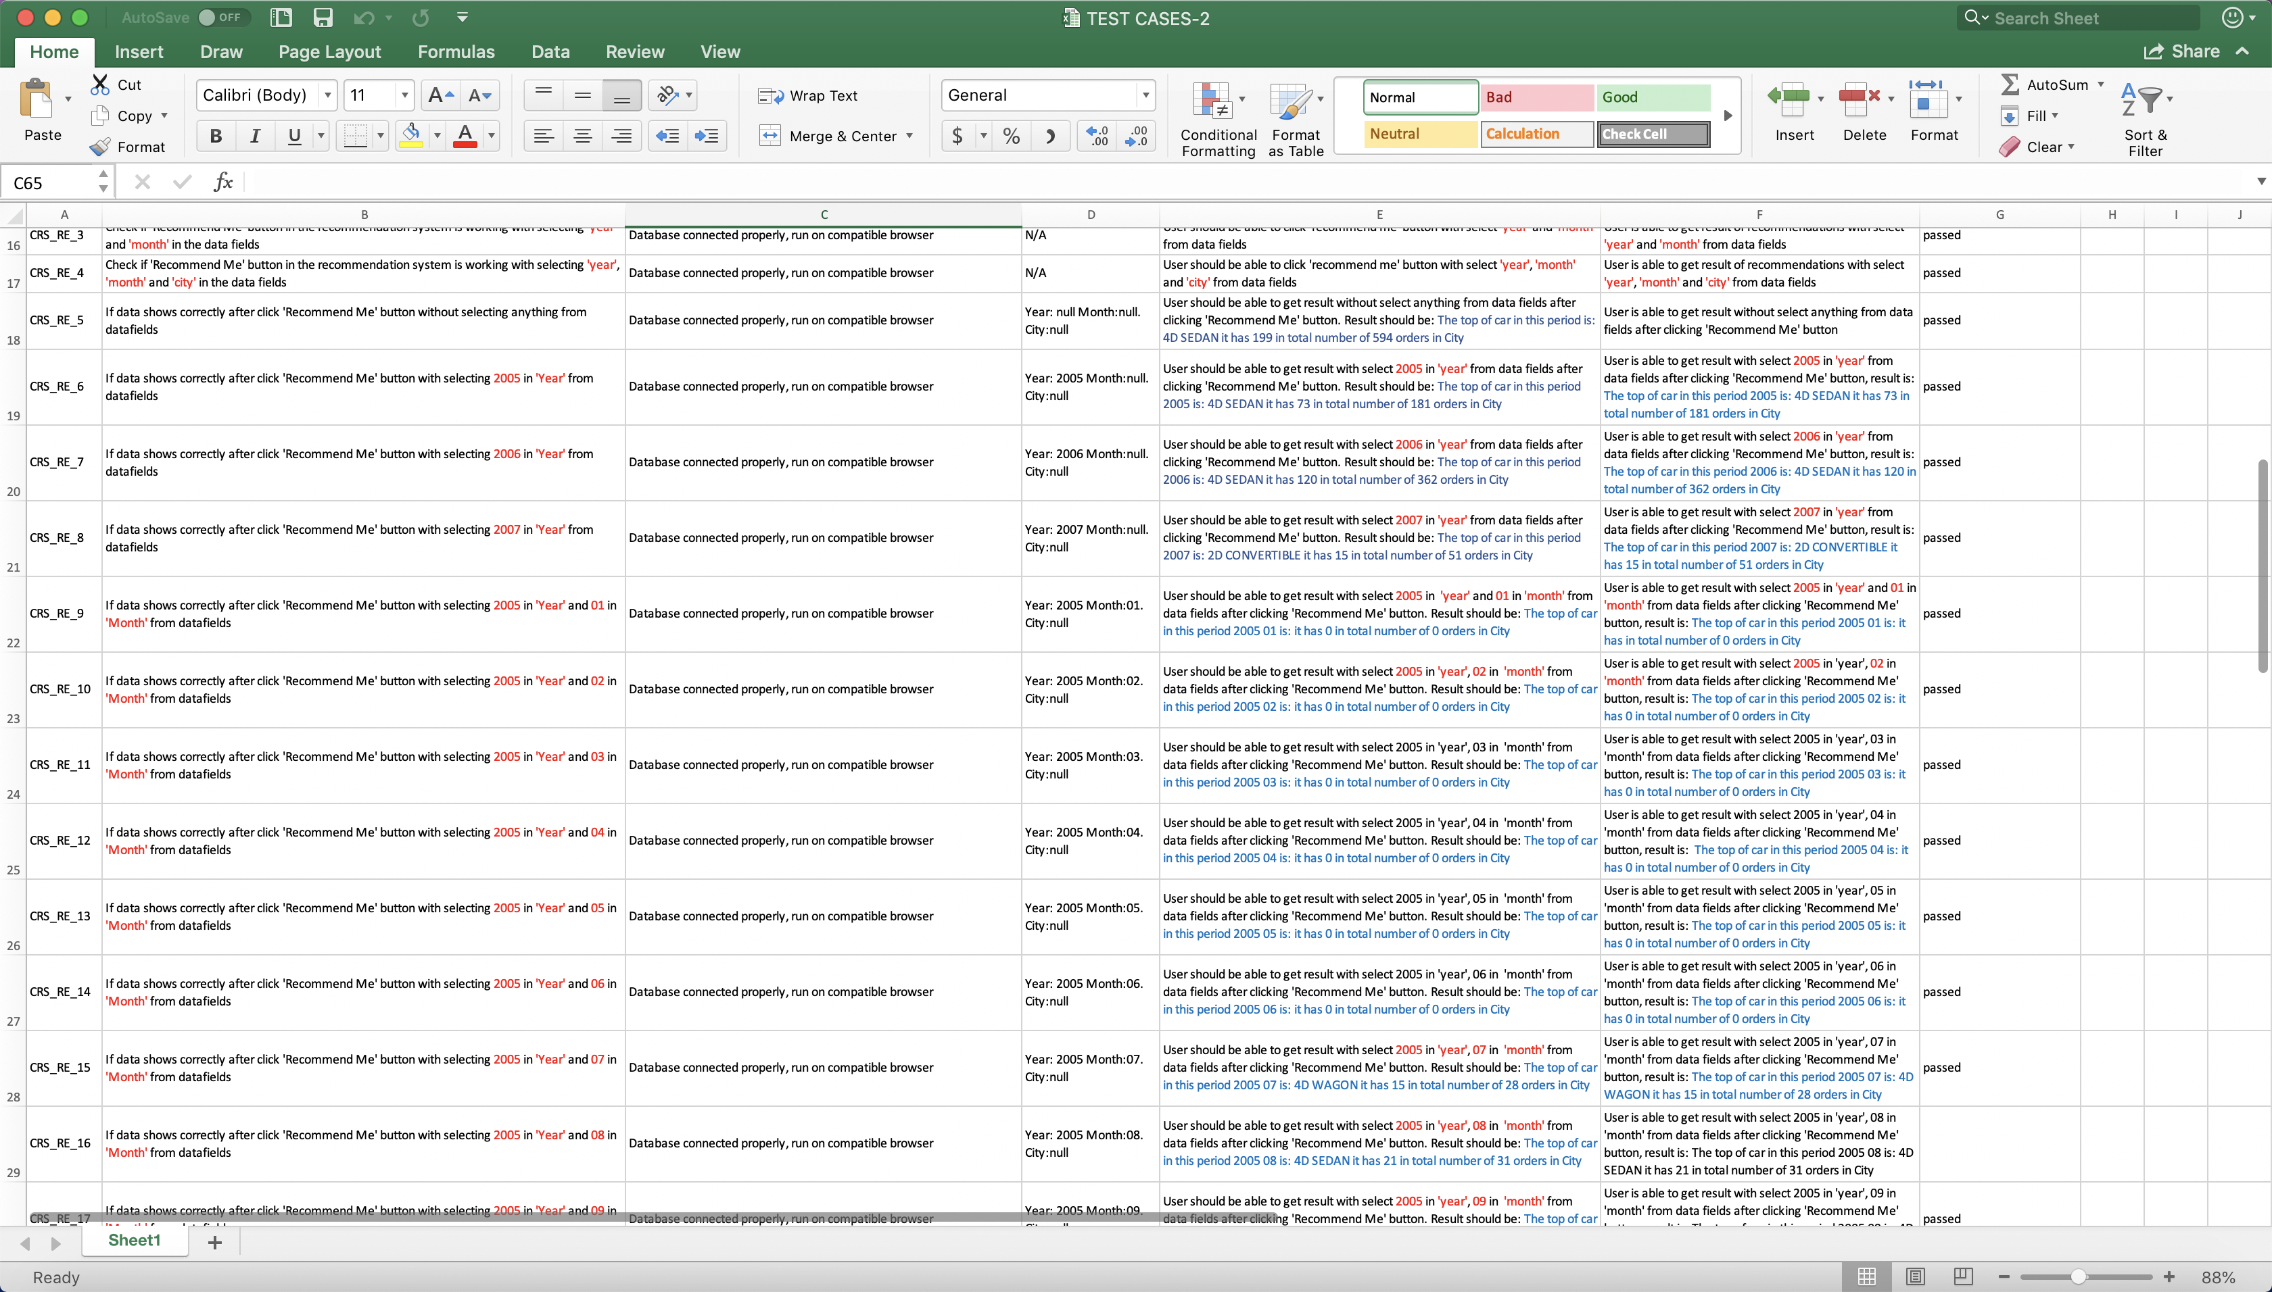

(Above shows manual test in the excel)

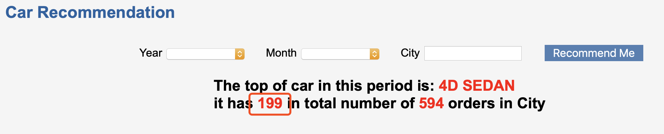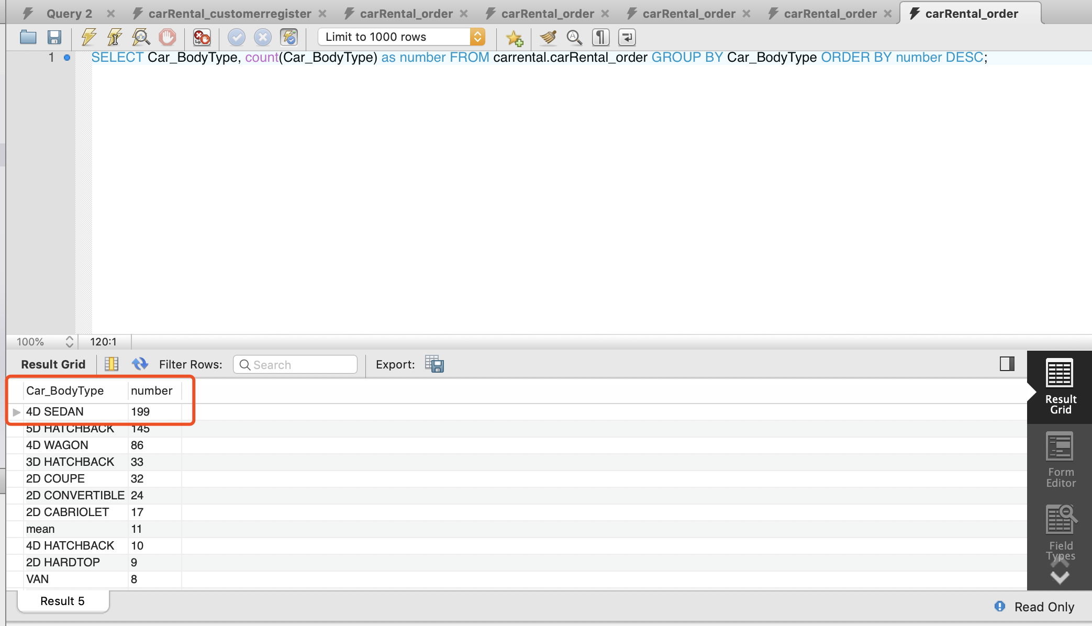

(Above pictures show top car type in the total order, result shows on the page and databse)

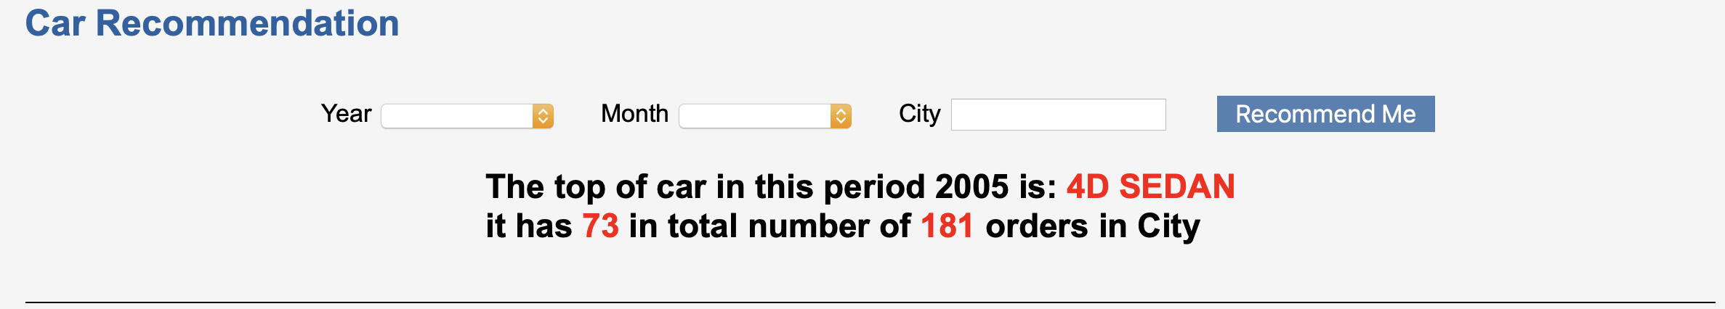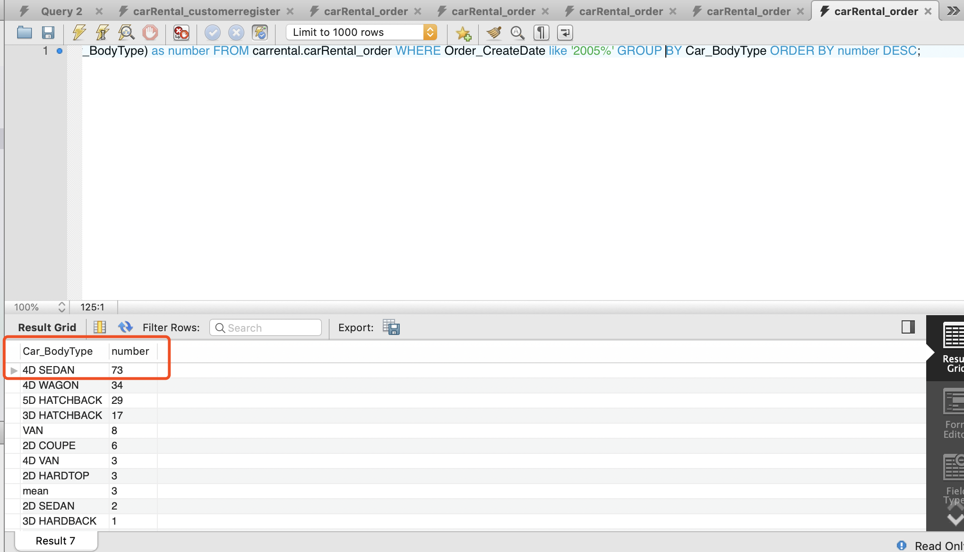

(Above pictures show top car type in the total order in 2005, result shows on the page and databse)

**Artefact5(Project deployment on server)**

This artefact is related to project deployment on web server which is required by our clients, this could help us to delivery project to our clients easier and for them easier to use, our clients can use our project remotely and don’t need to install anything on their computer, the only one thing they need to do is enter URL in their browser then they can use it which is very convenient. Our clients could run the project remotely as well such as run project on their phones, tablets or laptops. In this artefact, I have done several things: 1. I have rented a web server from AlibabaCloud which has Linux installed on that server. 2.I have installed basic Django environment on that server based on Linux system (mysql, python, Django etc.) 3. I have uploaded project and database to the server. 4. I have started project on the server. With this artefact, our team can delivery project efficiently and it is very good for our clients to use this project. (This artefact is done by myself)(*Images may not display properly on the server, still trying to fix it)

try it here:

<http://47.91.41.87:8000/carRental/homepage>

(if page shows ‘cannot connect to server’, please check solution in file Artefact5- ServerSolution.docx)

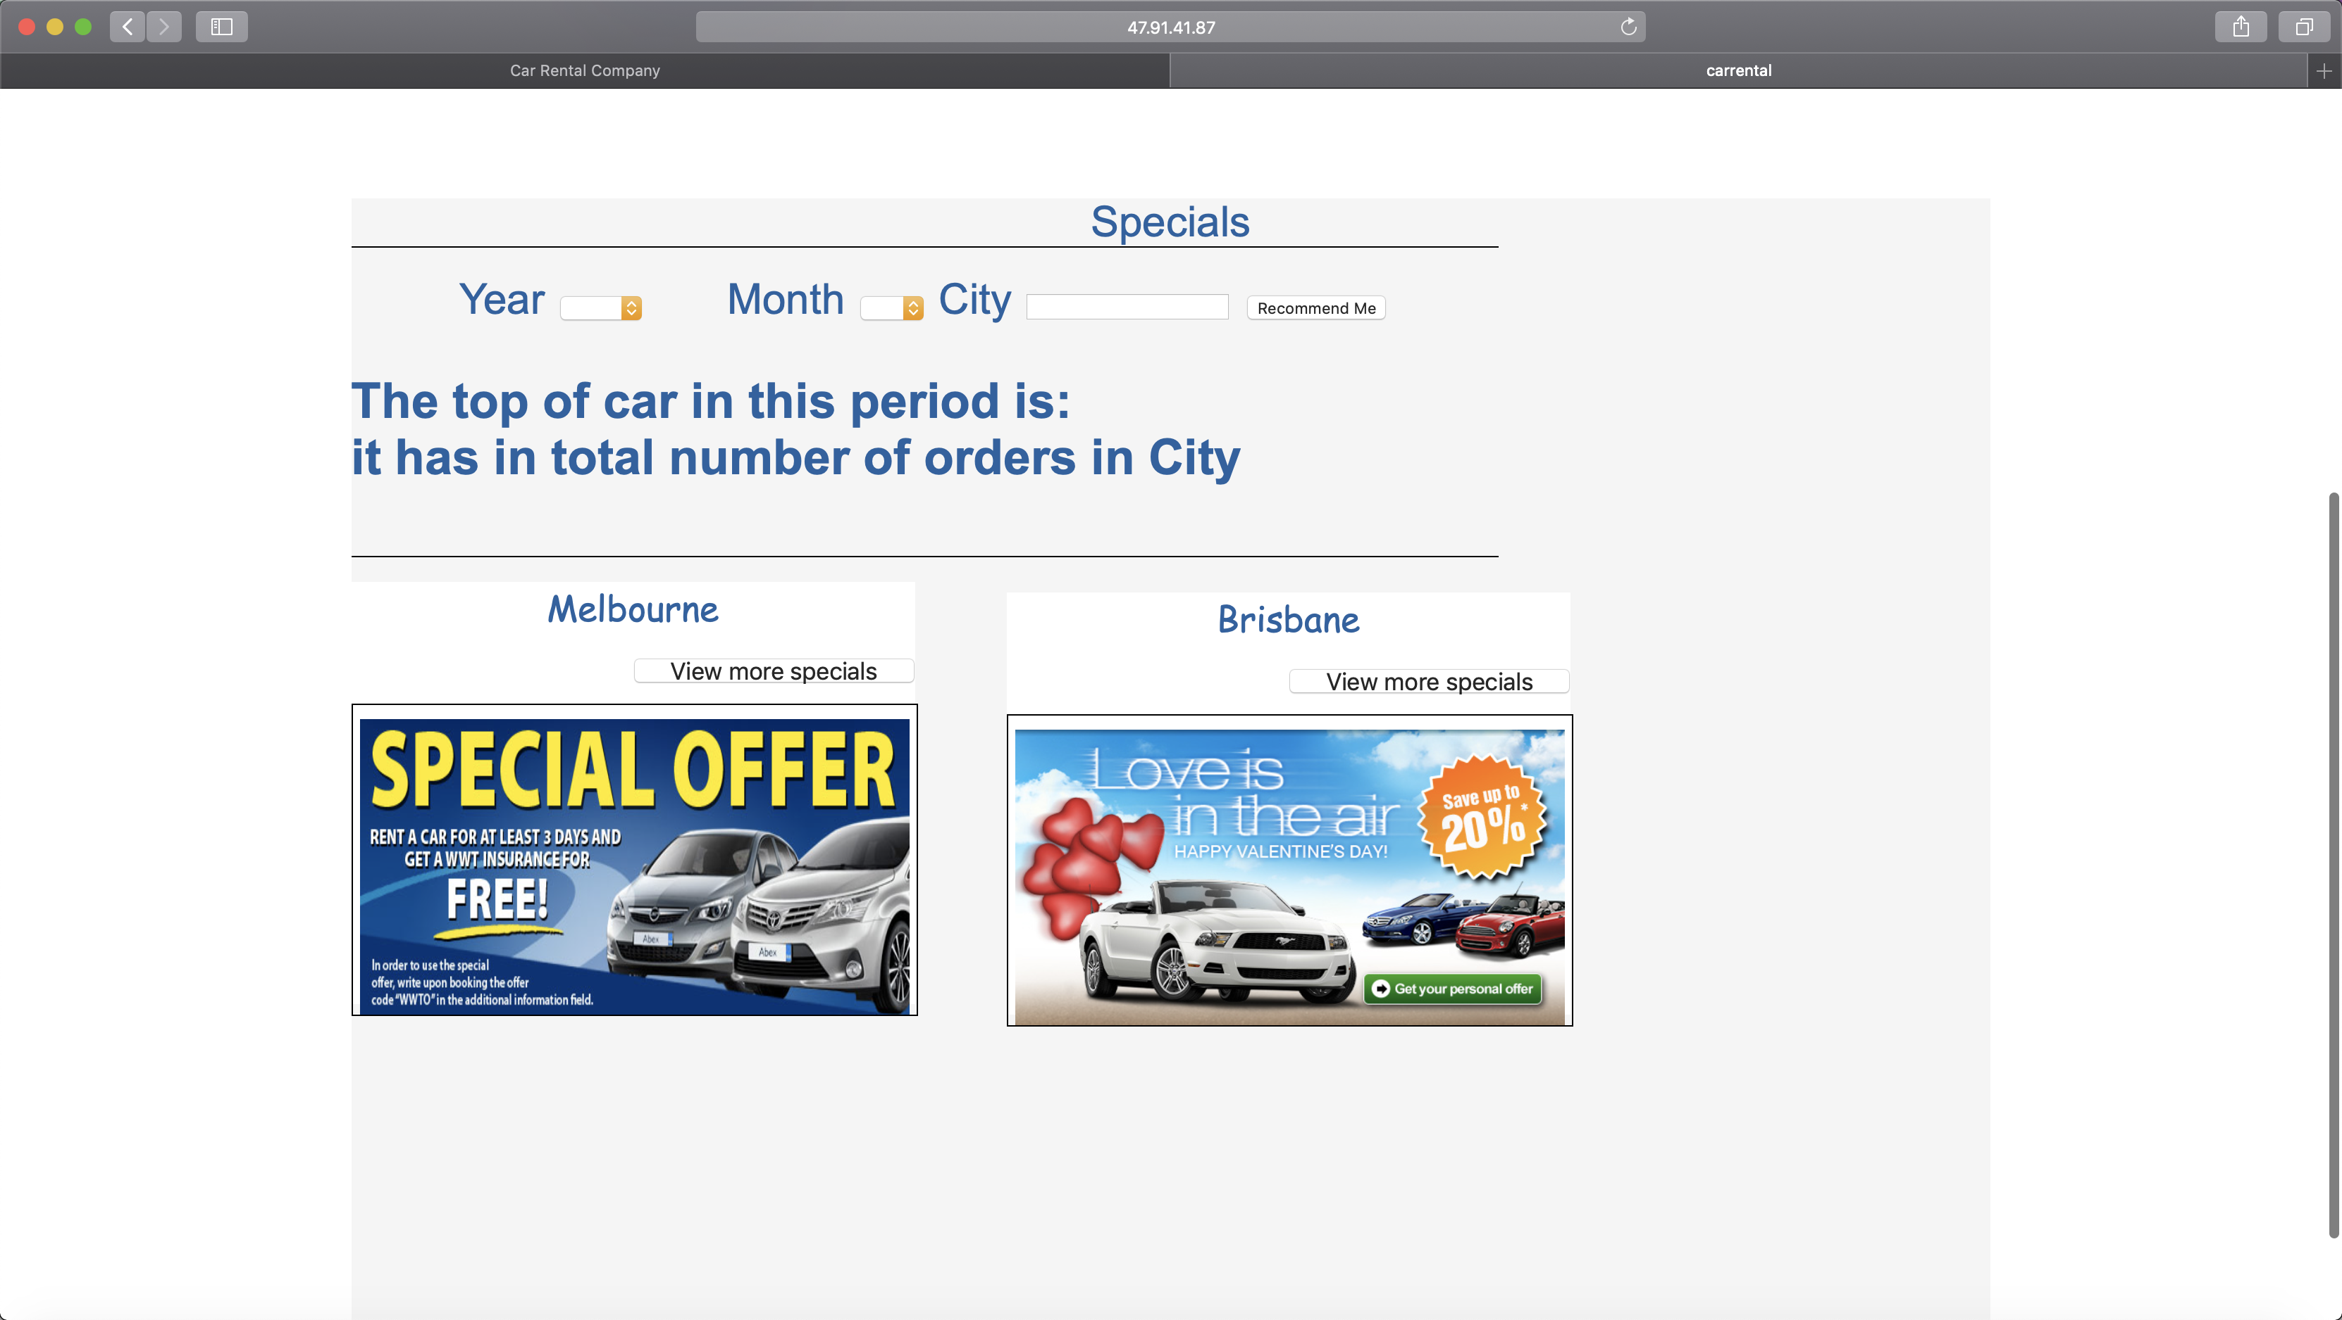

(Project running on Server)

http://47.91.41.87:8000/carRental/orderoverview

